This Document covers:  
1. Python and Pycharm download link and installation instructions

2. Jupyter Notebook installation instruction

3. Setting up the Environment variables

4. Setting up the Python interpreter for Pycharm

Please install the below applications in your **Fitch Cloud PC**. (Once you download them you should be able to install it by yourself by right clicking and **selecting ‘Request run as Administrator’**. If you cannot, then raise a service request to Service Desk)

* Python - <https://www.python.org/downloads/> (3.11.x)
* Pycharm - <https://www.jetbrains.com/pycharm/download/#section=windows>

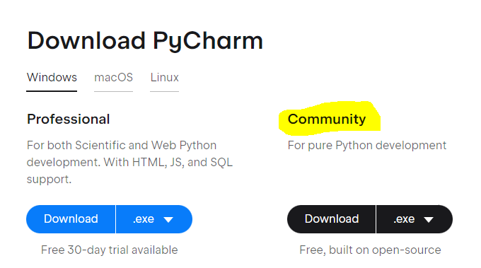

Installing the Jupyter Notebook

1. Open Pycharm and navigate to Terminal in the bottom left of Pycharm

1. Type in **pip install jupyter** and hit Enter

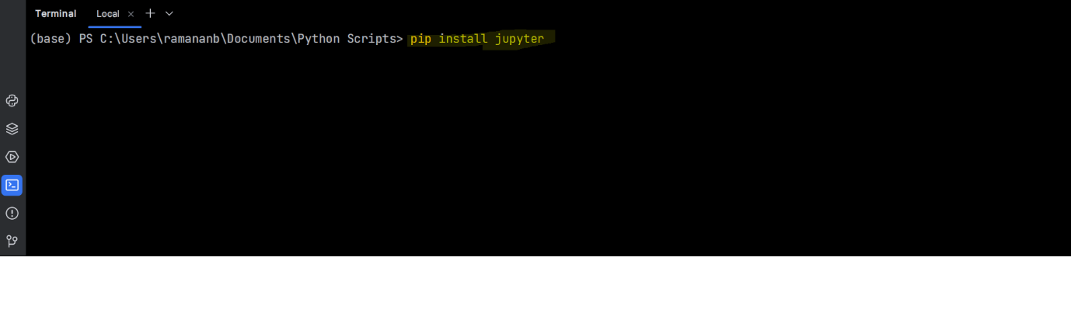

1. It will install the jupyter application
2. Once the installation in completed type in **jupyter notebook**

1. Now it should launch the Jupyter Notebook in chrome application. Create a new python notebook and you can start practicing.

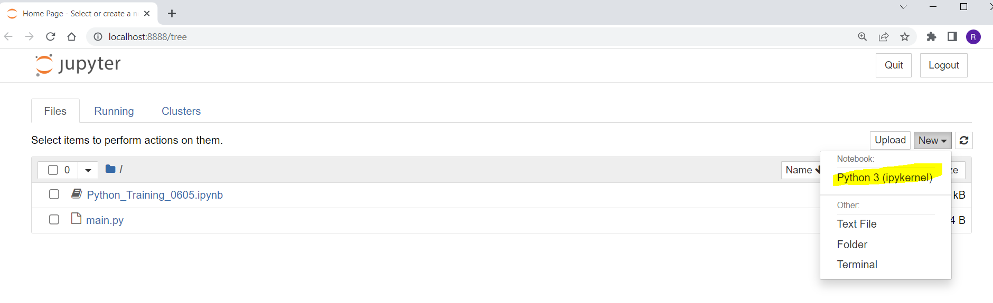

Setting up the Environment variables

1. Navigate to start -> search for **Manage app execution aliases**

1. Turn off any python.exe aliases

1. Go to start -> Search for **environment variables** and select Edit **environment variables for your account**

1. **Double click on the Path**

1. Click on **New** button and enter the below 2 paths one after the other as separate entries.

* The path where python.exe exists - Example : **C:\Users\username\AppData\Local\<PythonVersion>\** (**note**: this is the path where the python.exe resides. May vary based on your installation directory)
* Check if Scripts folder exists in the above Python folder. If yes, then include the below path.
* **C:\Users\username\AppData\Local\<PythonVersion>\Scripts**

**Click Ok.**

1. Navigate to cmd prompt and type **python --version ( it’s double hyphen version)**

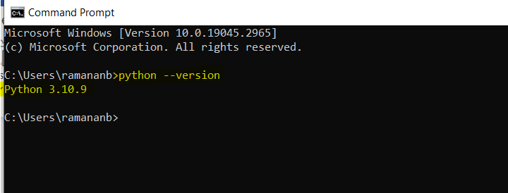

Setting up the Python Interpreter for Pycharm

1. Open Pycharm and navigate to File -> Settings -> Project -> Python Interpreter -> Add Interpreter

Select - System Interpreter and choose the python.exe by navigating to the corresponding directory and click ok.



